**VISVESVARAYA TECHNOLOGICAL UNIVERSITY**

**“JnanaSangama”, Belgaum-590014, Karnataka.**



**LAB REPORT**

**On**

**Object Oriented Java Programming**

**(23CS3PCOOJ)**

**Submitted by**

**DHRUVA S RAO (1BM23CS092)**

**In partial fulfilment for the award of the degree of**

**BACHELOR OF ENGINEERING**

**In**

**COMPUTER SCIENCE AND ENGINEERING**



**B.M.S COLLEGE OF ENGINEERING**

**(**Autonomous Institution under VTU)

**BENGALURU-560019**

**Sep-2024 to Jan-2025**

**B. M. S College of Engineering,**

**Bull Temple Road, Bengaluru-560019**

(Affiliated to Visvesvaraya Technological University, Belgaum)

**Department of Computer Science and Engineering**



**CERTIFICATE**

This is to certify that the Lab work entitled “Object Oriented Java Programming(23CSPCOOJ)”

carried out by **DHRUVA S RAO(1BM23CS092)**, who is a bonafide student of **BMS College of**

**Engineering**. It is in partial fulfilment for the award of **Bachelor of Engineering in Computer**

**Science and Engineering** of the Visvesvaraya Technological University, Belgaum during the year

2024. The Lab report has been approved as it satisfies the academic requirements in respect of a

Object Oriented Java Programming(23CSPCOOJ) work prescribed for the said degree.

|  |  |
| --- | --- |
| Dr. Swathi Sridharan  Assistant Professor  Department of CSE, BMSCE | Dr. Jyothi S Nayak  Professor HOD  Department of CSE, BMSCE |

|  |  |  |  |
| --- | --- | --- | --- |
| **Sl.**  **No.** | **Date** | **Experiment Title** | **Page No.** |
| 1 | **1/10/24** | **Quadratic Equation Implementation** | **4-6** |
| 2 | **8/10/24** | **Student’s SGPA Calculator** | **7-11** |
| 3 | **15/10/24** | **Book Information** | **11-15** |
| 4 | **22/10/24** | **Area of Shapes using Abstract class** | **15-18** |
| 5 | **22/10/24** | **Bank accounts** | **19-23** |
| 6 | **29/10/24** | **CIE and SEE Packages Implementation** | **24-28** |
| 7 | **12/11/24** | **Exception Handling** | **28-31** |
| 8 | **26/11/24** | **Thread Program Implementation** | **32-34** |
| 9 | **3/12/24** | **Interface Implementation** | **34-37** |
| 10 | **3/12/24** | **Inter Process Communication and Deadlock** | **37-39** |

**Github Link:**

[**https://github.com/DhruvaSRao64/Java-Program**](https://github.com/DhruvaSRao64/Java-Program)

**Program 1**

**Implement Quadratic Equation**

Develop a Java program that prints all real solutions to the quadratic equation ax2 +bx+c = 0. Read in a, b, c and use the quadratic formula. If the discriminate b2 -4ac is negative, display a message stating that there are no real solutions**.**

**Source code:**

import java.util.Scanner;

public class Quadratic {

public static void main(String[] args){

Scanner scanner = new Scanner(System.in);

System.out.println("Enter the coefficient a: ");

double a = scanner.nextDouble();

System.out.println("Enter the coefficient b: ");

double b = scanner.nextDouble();

System.out.println("Enter the coefficient c: ");

double c = scanner.nextDouble();

if (a == 0) {

System.out.println("Invalid coefficient of a!");

}

double disc = (b*b) - (4 * a * c);

if (disc > 0) {

double root1 = -b + (Math.sqrt(disc)/(2 * a));

double root2 = -b - (Math.sqrt(disc)/(2 * a));

System.out.println("Roots are real and distinct");

System.out.println("The first root is: "+root1+"\n The second root is: "+root2);

} else if (disc == 0) {

double root1 = -b/ (2 * a);

double root2 = root1;

System.out.println("Roots are real and equal");

System.out.println("The roots are: "+root1+"\n"+root2);

} else {

double realPart = -b/ (2 * a);

double imagPart = Math.sqrt(-disc)/ (2 * a);

System.out.println("The equation has complex roots");

System.out.println("The real root is: "+realPart+"\nThe imaginary part is: "+imagPart);

}

scanner.close();

}

}

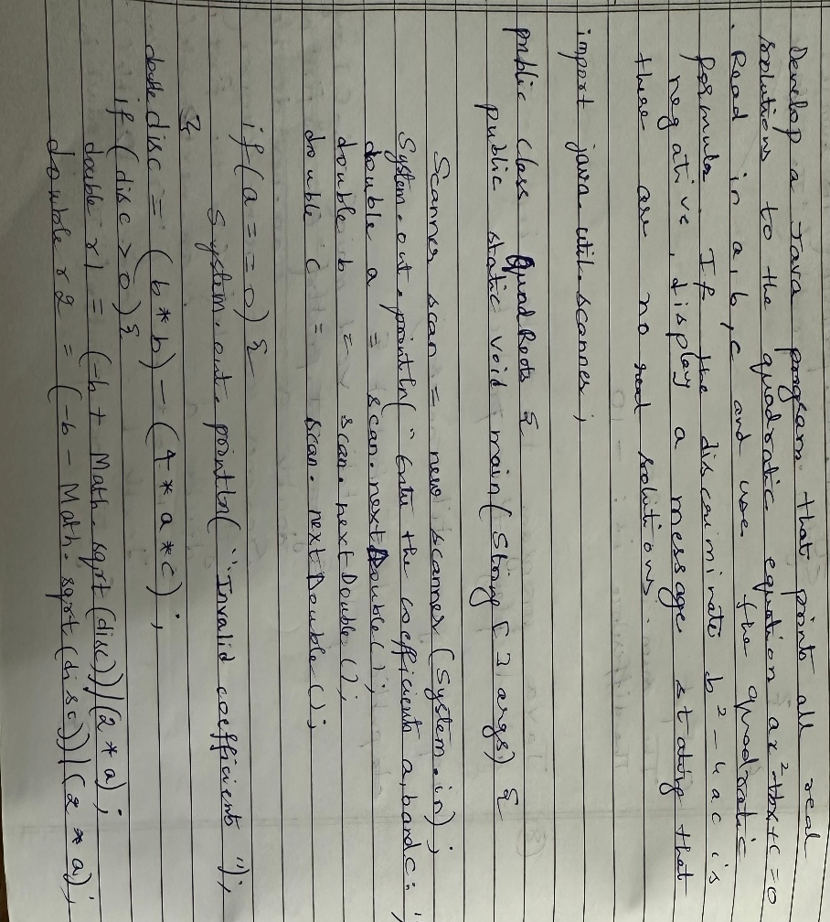

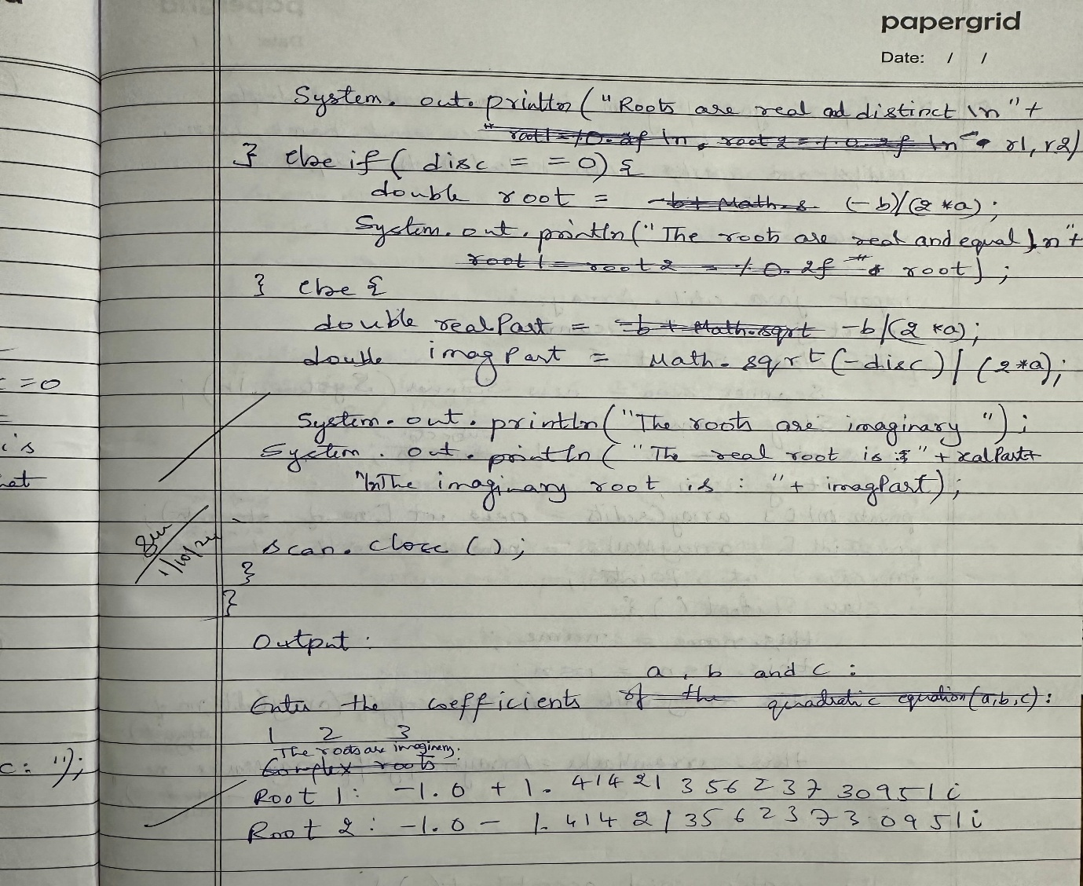

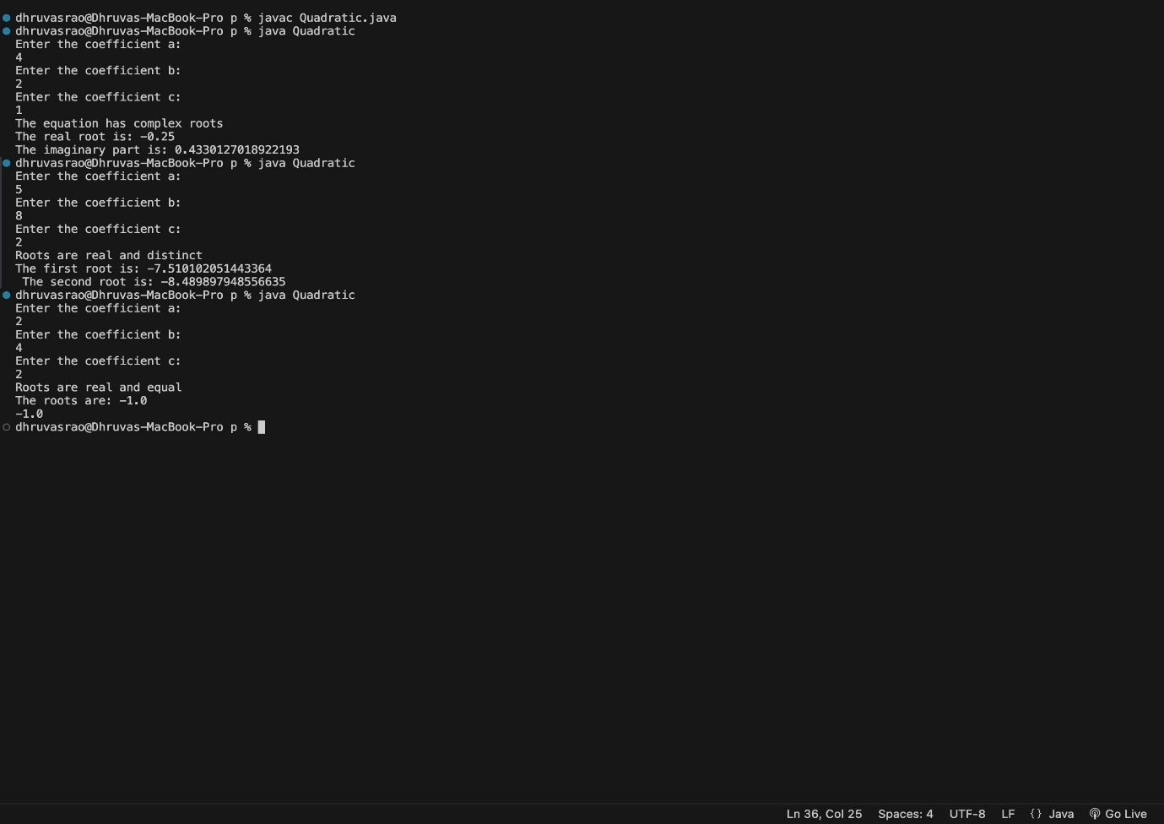

**OUTPUT 1**

**Program 2**

**Student’s SGPA Calculator**

Develop a Java program to create a class Student with members usn, name, an array credits and an array marks. Include methods to accept and display details and a method to calculate SGPA of a student.

**Source Code:**

import java.util.Scanner;

class Student {

private String usn;

private String name;

private int [] credits;

private int [] marks;

public void acceptDetails () {

Scanner scanner = new Scanner (System.in);

System.out.print("Enter USN: ");

usn = scanner.nextLine();

System.out.print("Enter Name: ");

name = scanner.nextLine();

System.out.print("Enter number of subjects: ");

int n = scanner.nextInt();

credits = new int[n];

marks = new int[n];

for (int i = 0; i < n; i++) {

System.out.print("Enter credits for subject " + (i + 1) + ": ");

credits[i] = scanner.nextInt();

System.out.print("Enter marks for subject " + (i + 1) + ": ");

marks[i] = scanner.nextInt();

}

scanner.close();

}

public void displayDetails() {

System.out.println("USN: " + usn);

System.out.println("Name: " + name);

System.out.println("Subject Details:");

for (int i = 0; i < credits.length; i++) {

System.out.println("Subject " + (i + 1) + " - Credits: " + credits[i] + ", Marks: " + marks[i]);

}

}

public double calculateSGPA() {

int totalCredits = 0;

int weightedGradePoints = 0;

for (int i = 0; i < credits.length; i++) {

int gradePoints = getGradePoints(marks[i]);

weightedGradePoints += gradePoints * credits[i];

totalCredits += credits[i];

}

if (totalCredits == 0) {

return 0.0;

}

return (double) weightedGradePoints / totalCredits;

}

private int getGradePoints(int marks) {

if (marks >= 90) return 10;

if (marks >= 80) return 9;

if (marks >= 70) return 8;

if (marks >= 60) return 7;

if (marks >= 50) return 6;

if (marks >= 40) return 5;

return 0;

}

}

public class StudentSGPACalculator {

public static void main(String[] args) {

Student student = new Student();

student.acceptDetails();

student.displayDetails();

double sgpa = student.calculateSGPA();

System.out.println("SGPA: " + sgpa);

}

}

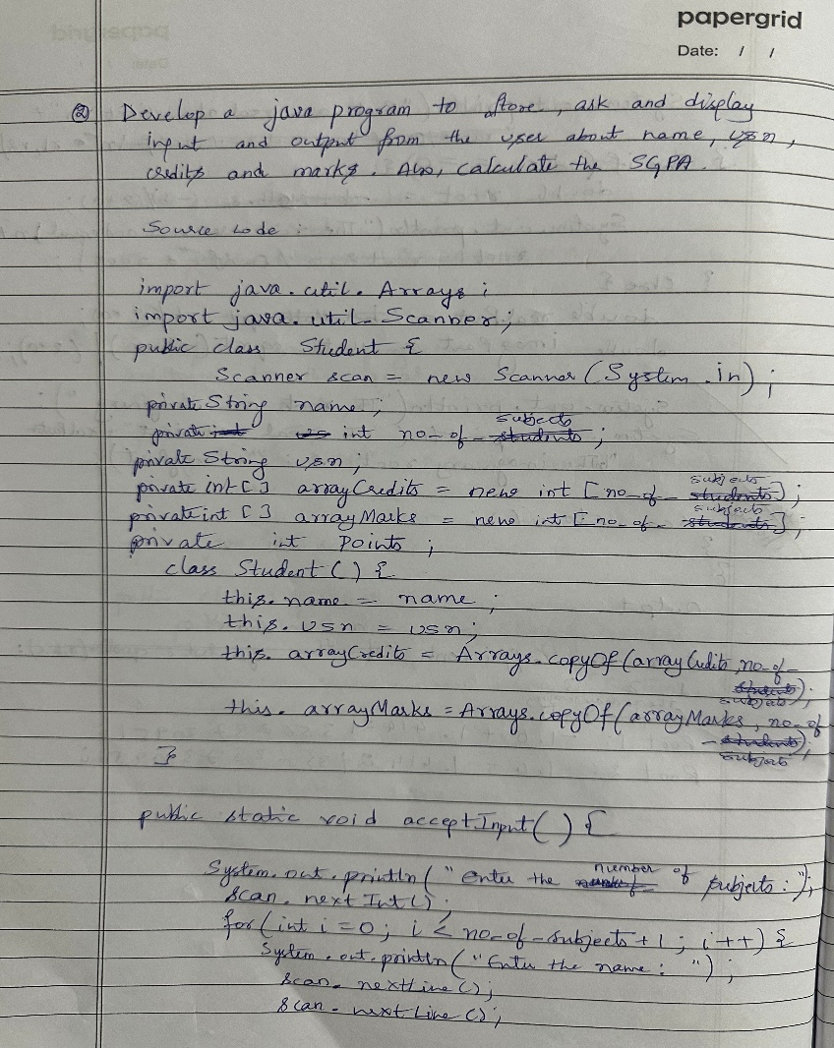

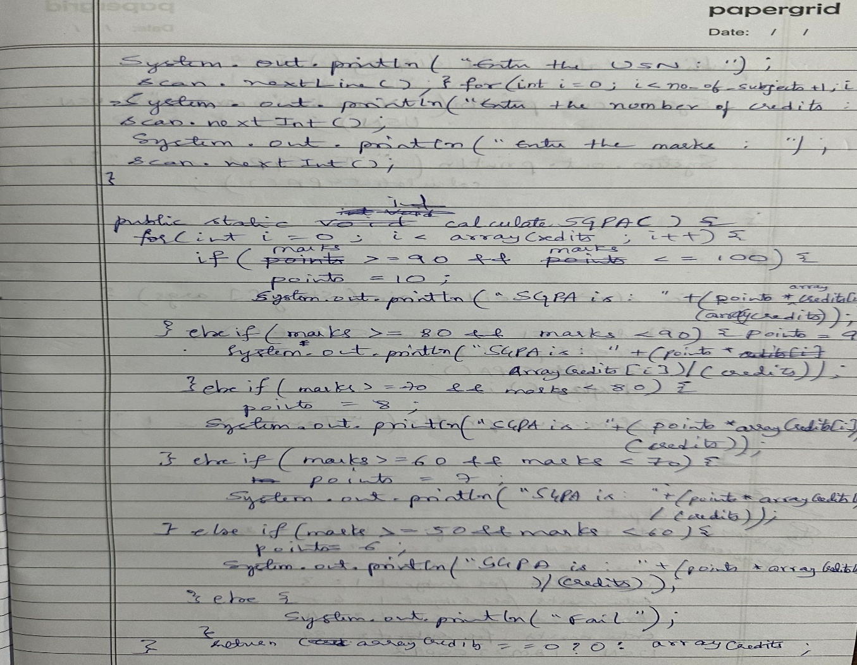

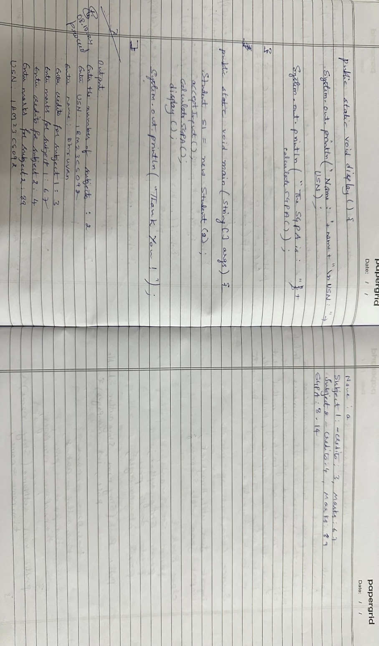

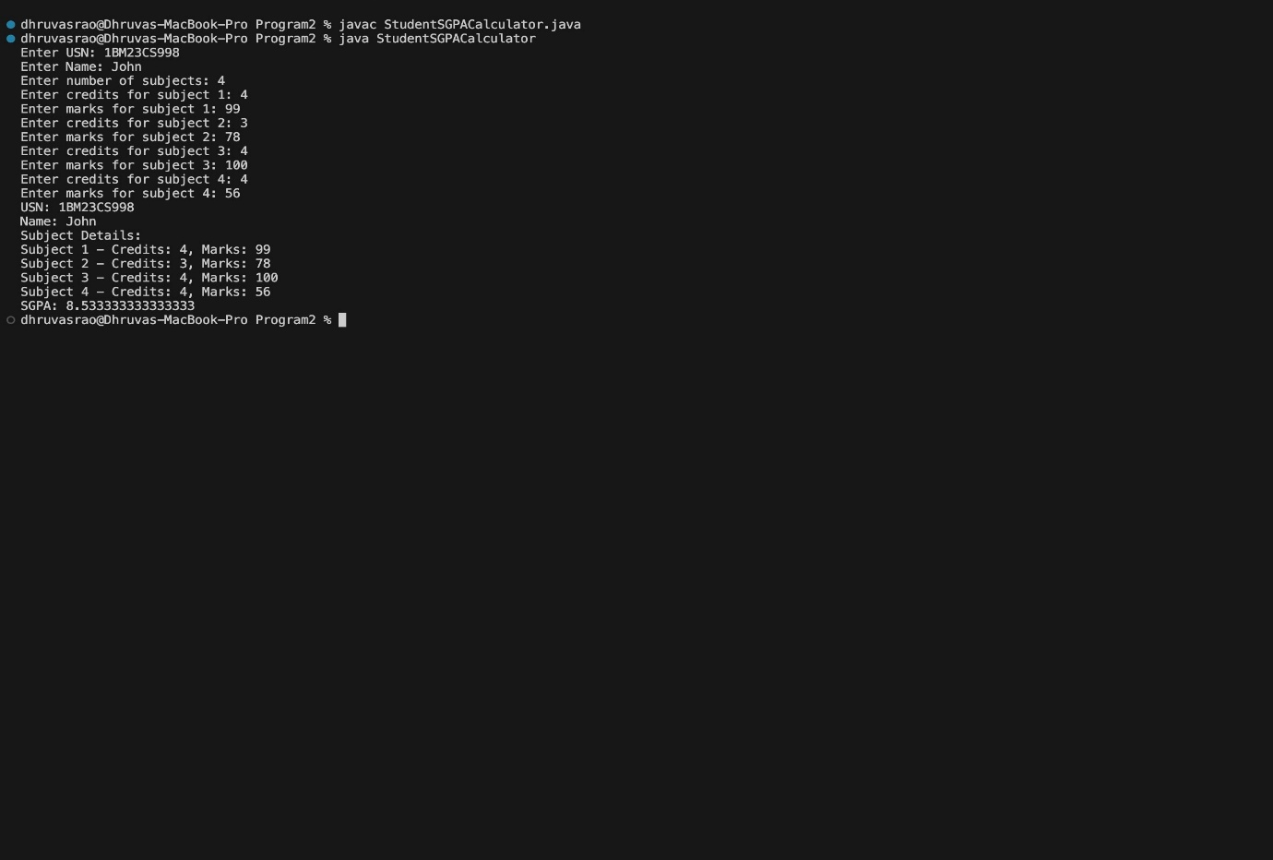

**OUTPUT 2**

**Program 3**

**Book Information**

Create a class Book which contains four members: name, author, price, num_pages. Include a constructor to set the values for the members. Include methods to set and get the details of the objects. Include a toString( ) method that could display the complete details of the book. Develop a Java program to create n book objects

**Source code:**

import java.util.Scanner;

public class Book {

String name;

String author;

double price;

int num_pages;

public Book (String name, String author, double price, int num_pages){

this.name = name;

this.author = author;

this.price = price;

this.num_pages = num_pages;

}

public String getName(){

return name;

}

public void setName(String name){

this.name = name;

}

public String getAuthor(){

return author;

}

public void setAuthor(String author){

this.author = author;

}

public double getPrice(){

return price;

}

public void setPrice(double price){

this.price = price;

}

public int getNumPages(){

return num_pages;

}

public void setNumPages(int num_pages){

this.num_pages = num_pages;

}

@Override

public String toString(){

return "The book name is: "+name+"\nAuthor: "+author+"\nPrice: "+price+"Number of pages: "+num_pages;

}

}

public class Main {

public static void main(String[] args) {

Scanner scanner = new Scanner(System.in);

System.out.println("Enter the number of books: ");

int n = scanner.nextInt();

scanner.nextLine();

Book[] book = new Book[n];

System.out.println("Enter the details: ");

for (int i = 0; i < n; i++){

System.out.println("Enter the name for "+"Book: "+(i+1));

String name = scanner.nextLine();

System.out.println("Enter the author name: ");

String author = scanner.nextLine();

System.out.println("Enter the price: ");

double price = scanner.nextDouble();

System.out.println("Enter the number of pages: ");

int num_pages = scanner.nextInt();

scanner.nextLine();

book[i] = new Book(name, author, price, num_pages);

}

System.out.println("The book details is: ");

for (Book books: book){

System.out.println(books.toString());

}

scanner.close();

}

}

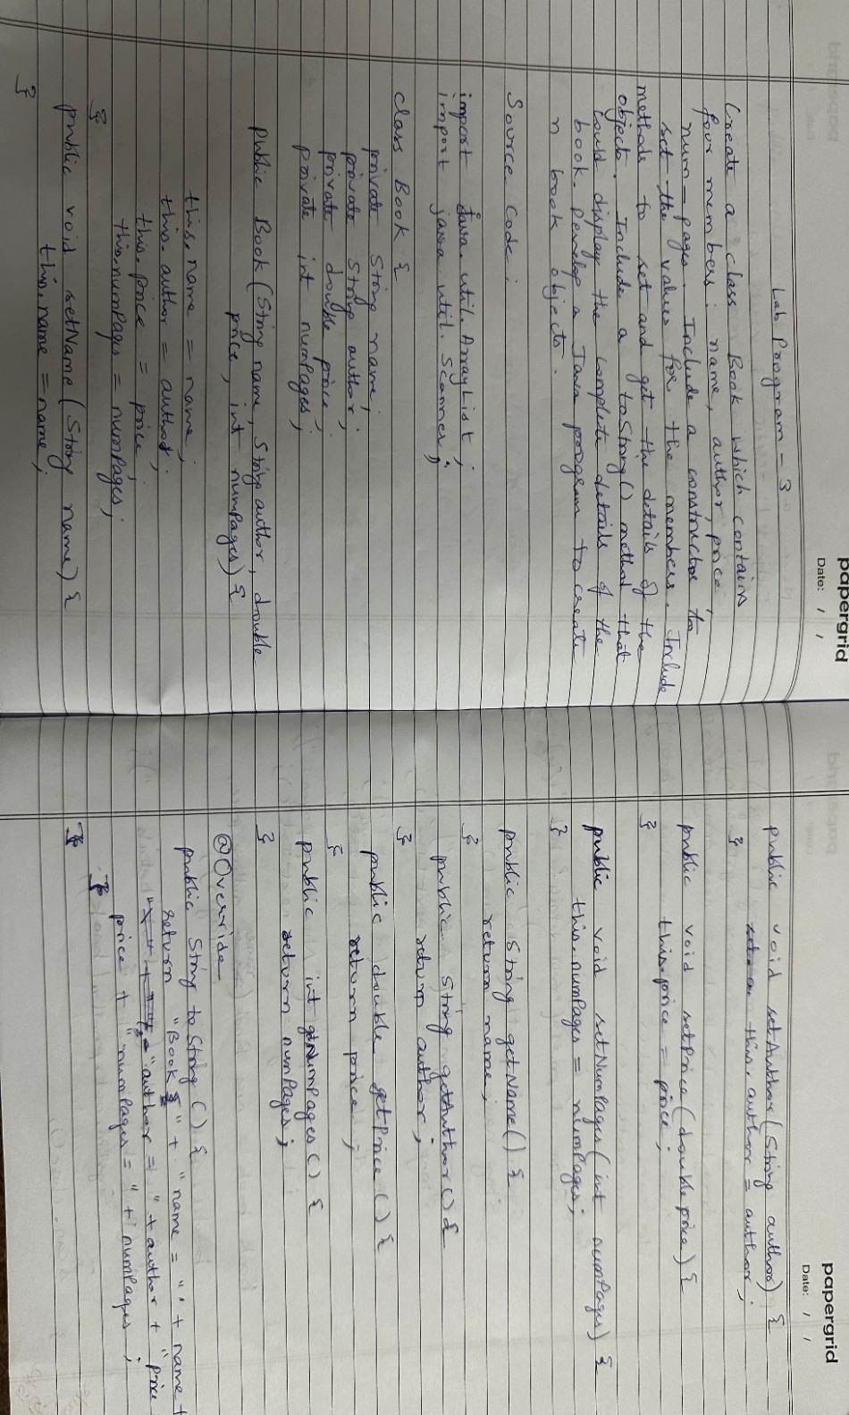

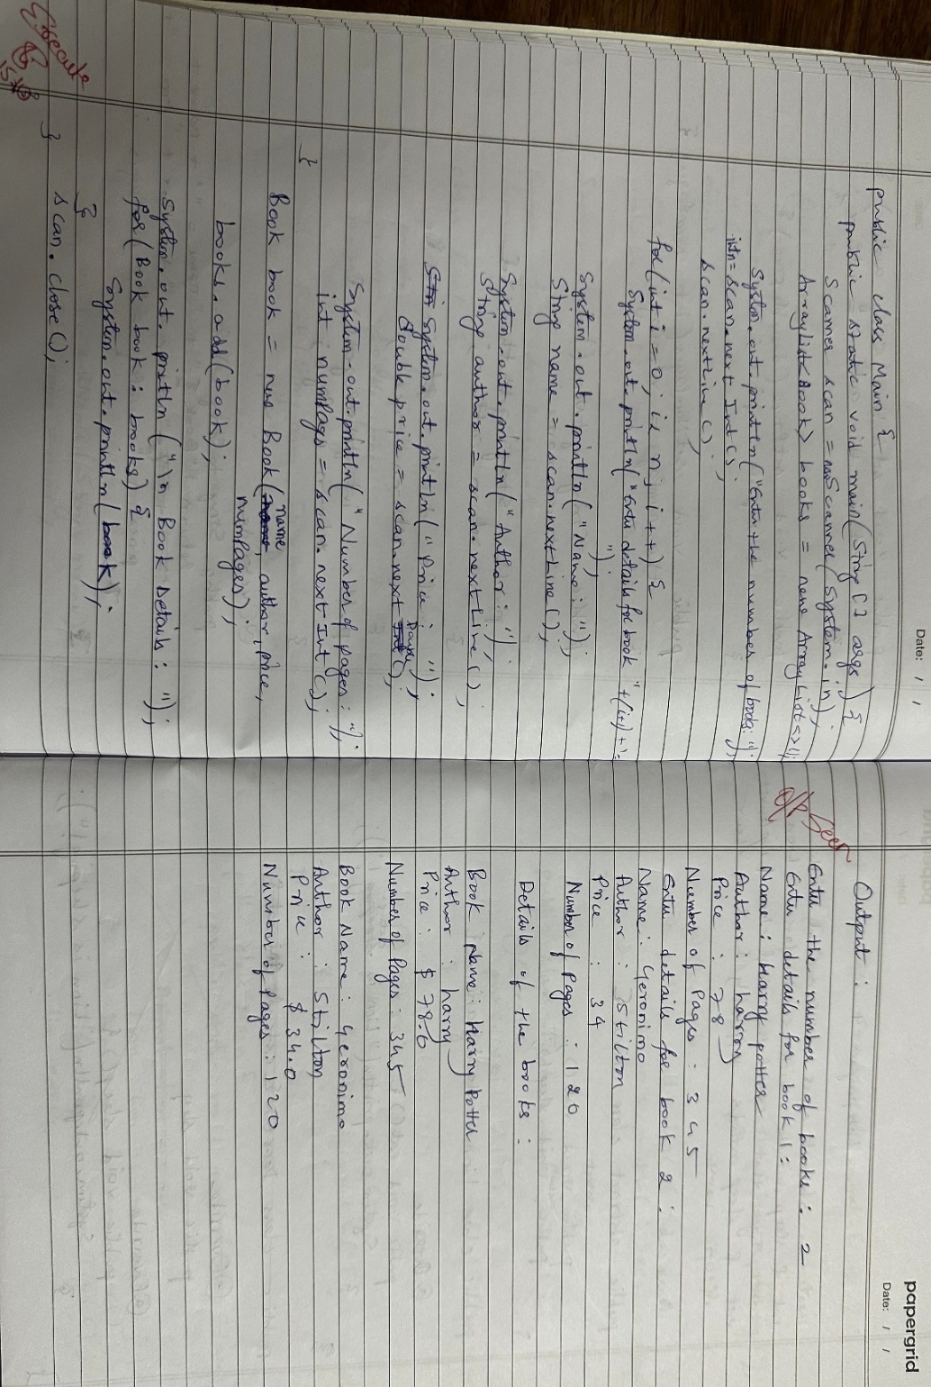

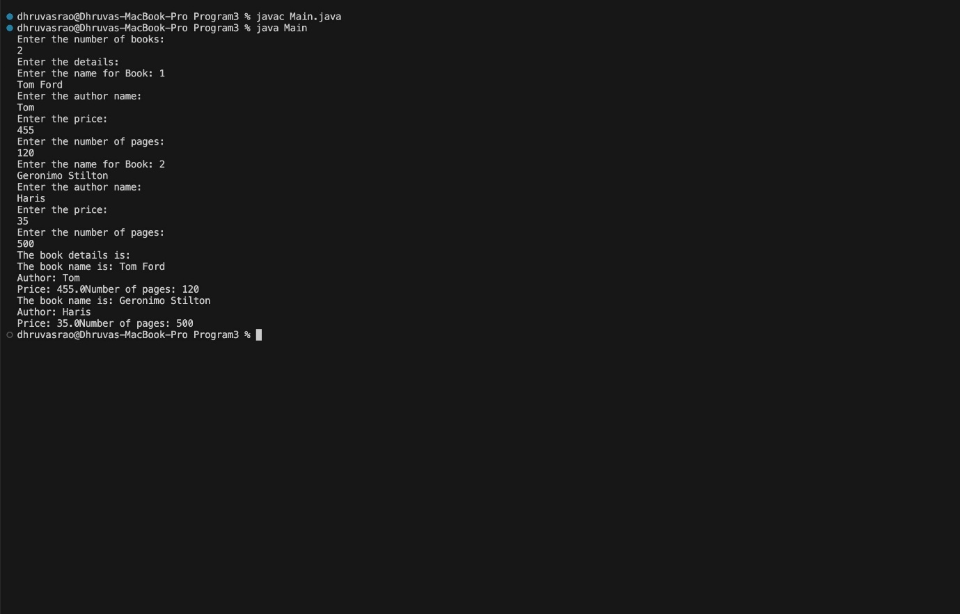

**OUTPUT 3**

**Program 4**

**Area of Shapes using Abstract class**

Develop a Java program to create an abstract class named Shape that contains two integers and an empty method named printArea(). Provide three classes named Rectangle, Triangle and Circle such that each one of the classes extends the class Shape. Each one of the classes contain only the method printArea() that prints the area of the given shape.

**Source code:**

public abstract class Shape{

double a;

double b;

public Shape(double a, double b){

this.a = a;

this.b = b;

}

public abstract void printArea();

}

public class Rectangle extends Shape {

public Rectangle(double a, double b){

super(a,b);

}

@Override

public void printArea(){

double area = a * b;

System.out.println("The area of the rectangle is: "+area);

}

}

public class Triangle extends Shape {

public Triangle(double a, double b){

super(a,b);

}

@Override

public void printArea(){

double area = (0.5 * a * b);

System.out.println("The area of the triangle is: "+area);

}

}

public class Circle extends Shape {

public Circle(double a, double b){

super(a,b);

}

@Override

public void printArea(){

double area = Math.PI * a * a;

System.out.println("The area of the Circle is: "+area);

}

}

public class Main {

public static void main(String[] args){

Rectangle rectangle = new Rectangle(10, 20);

Triangle trinagle = new Triangle(10, 20);

Circle circle = new Circle(10, 20);

rectangle.printArea();

trinagle.printArea();

circle.printArea();

}

}

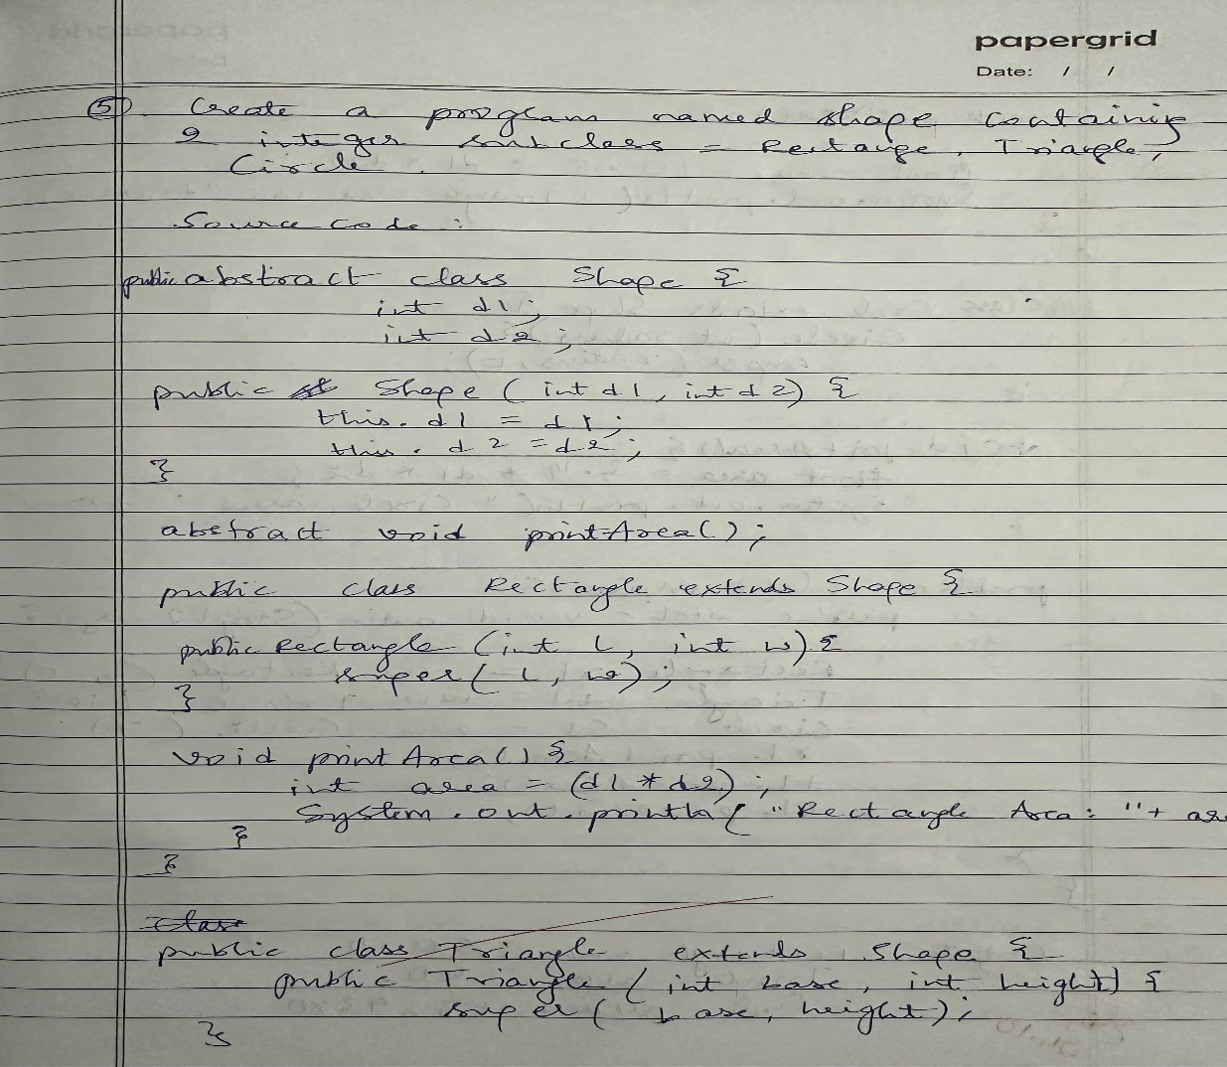

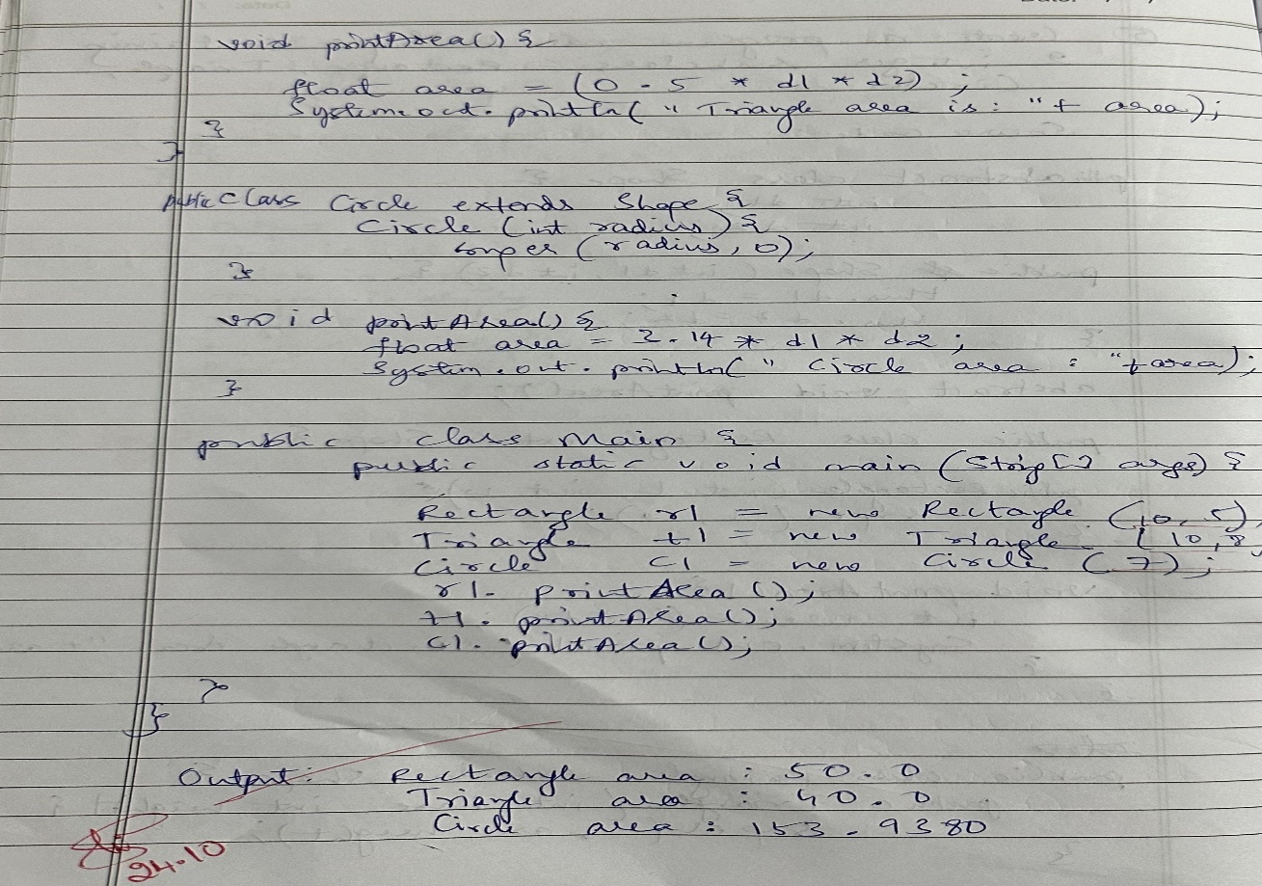

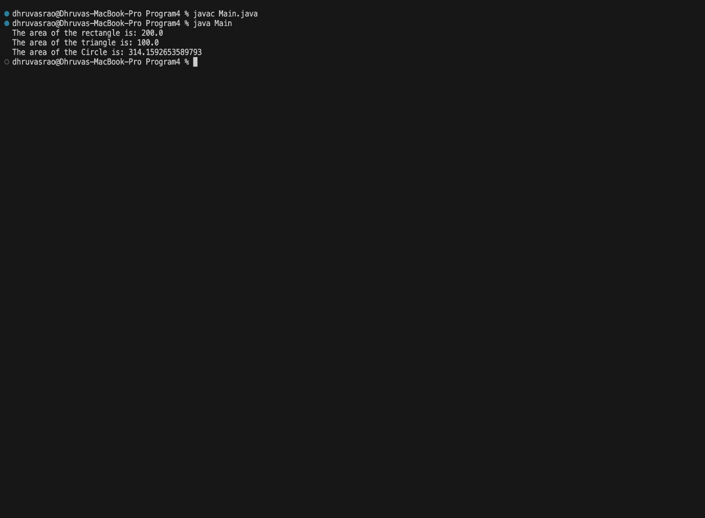

**OUTPUT 4**

**Program 5**

**Bank Account**

Develop a Java program to create a class Bank that maintains two kinds of account for its customers, one called savings account and the other current account. The savings account provides compound interest and withdrawal facilities but no cheque book facility. The current account provides cheque book facility but no interest. Current account holders should also maintain a minimum balance and if the balance falls below this level, a service charge is imposed. Create a class Account that stores customer name, account number and type of account. From this derive the classes Cur-acct and Sav-acct to make them more specific to their requirements. Include the necessary methods in order to achieve the following tasks: a) Accept deposit from customer and update the balance. b) Display the balance. c) Compute and deposit interest d) Permit withdrawal and update the balance Check for the minimum balance, impose penalty if necessary and update the balance.

**Source code:**

import java.util.Scanner;

public class Bank {

public static void main(String[] args) {

Scanner scanner = new Scanner(System.in);

SavAcct savings = new SavAcct("Alice", "S12345", 5000);

CurAcct current = new CurAcct("Bob", "C12345", 2000);

System.out.println("Savings Account:");

savings.displayBalance();

savings.deposit(1000);

savings.displayBalance();

savings.computeAndDepositInterest();

savings.displayBalance();

savings.withdraw(2000);

savings.displayBalance();

System.out.println("\nCurrent Account:");

current.displayBalance();

current.deposit(500);

current.displayBalance();

current.withdraw(2500);

current.displayBalance();

current.withdraw(300);

current.displayBalance();

scanner.close();

}

}

class SavAcct extends Account {

private static final double INTEREST_RATE = 0.04;

public SavAcct(String customerName, String accountNumber, double initialBalance) {

super(customerName, accountNumber, "Savings", initialBalance);

}

public void computeAndDepositInterest() {

double interest = balance * INTEREST_RATE;

balance += interest;

System.out.println("Interest deposited: " + interest);

}

public void withdraw(double amount) {

if (amount > 0 && amount <= balance) {

balance -= amount;

System.out.println("Withdrawn: " + amount);

} else {

System.out.println("Invalid withdrawal amount or insufficient balance.");

}

}

}

class CurAcct extends Account {

private static final double MIN_BALANCE = 1000.0;

private static final double PENALTY = 50.0;

public CurAcct(String customerName, String accountNumber, double initialBalance) {

super(customerName, accountNumber, "Current", initialBalance);

}

public void withdraw(double amount) {

if (amount > 0 && amount <= balance) {

balance -= amount;

System.out.println("Withdrawn: " + amount);

checkMinimumBalance();

} else {

System.out.println("Invalid withdrawal amount or insufficient balance.");

}

}

private void checkMinimumBalance() {

if (balance < MIN_BALANCE) {

balance -= PENALTY;

System.out.println("Balance fell below minimum. Penalty imposed: " + PENALTY);

}

}

}

class Account {

protected String customerName;

protected String accountNumber;

protected String accountType;

protected double balance;

public Account(String customerName, String accountNumber, String accountType, double initialBalance) {

this.customerName = customerName;

this.accountNumber = accountNumber;

this.accountType = accountType;

this.balance = initialBalance;

}

public void deposit(double amount) {

if (amount > 0) {

balance += amount;

System.out.println("Deposited: " + amount);

} else {

System.out.println("Invalid deposit amount.");

}

}

public void displayBalance() {

System.out.println("Balance: " + balance);

}

}

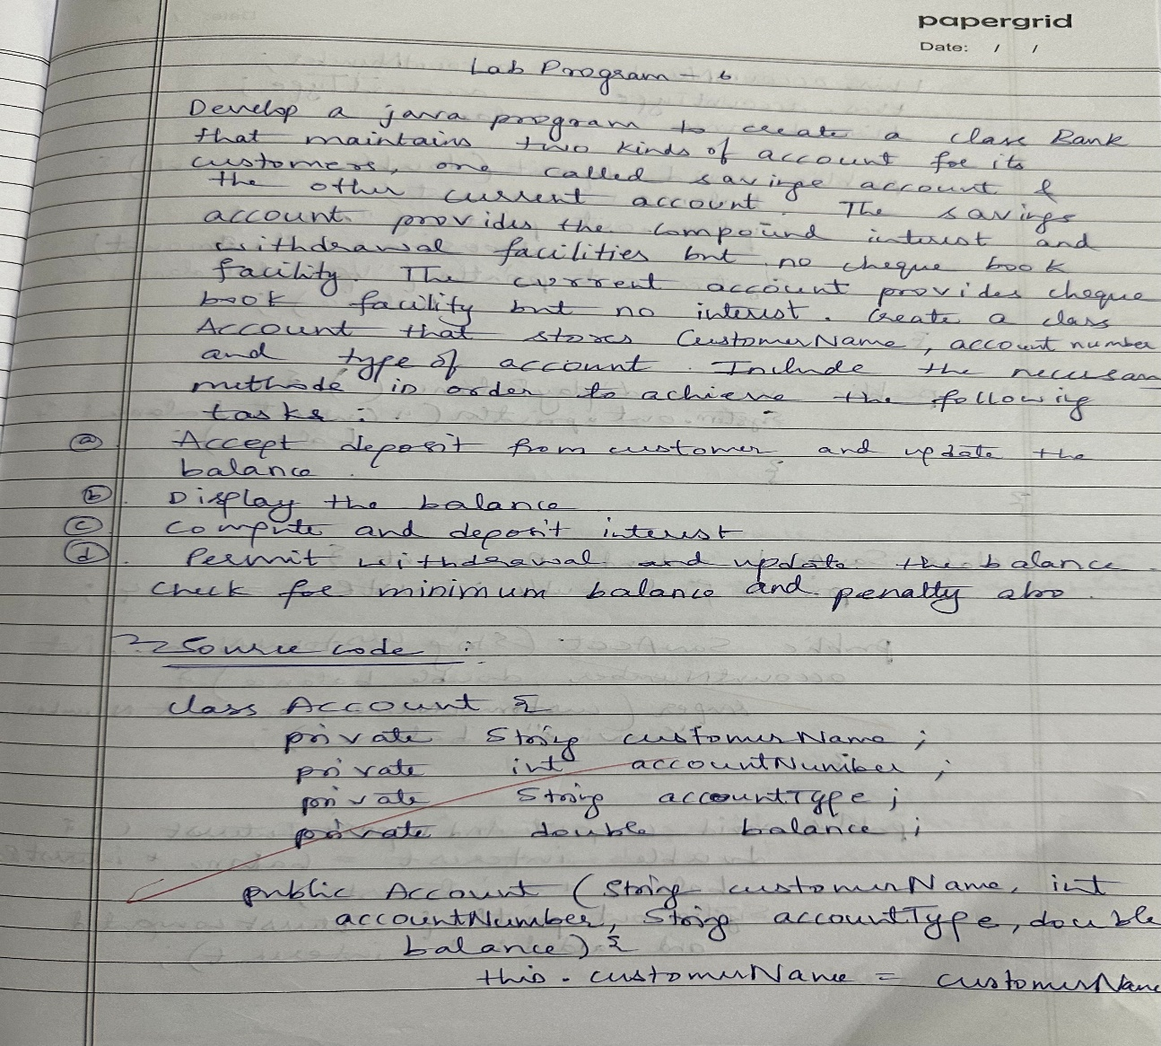

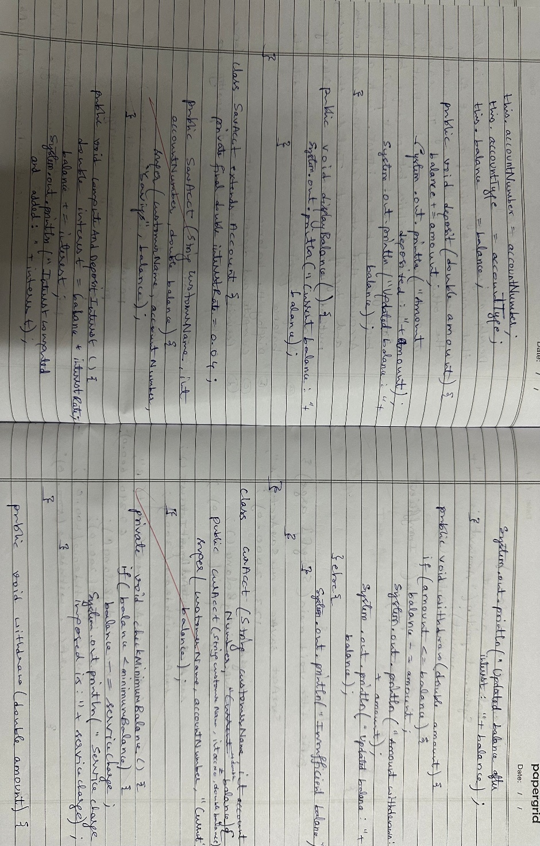

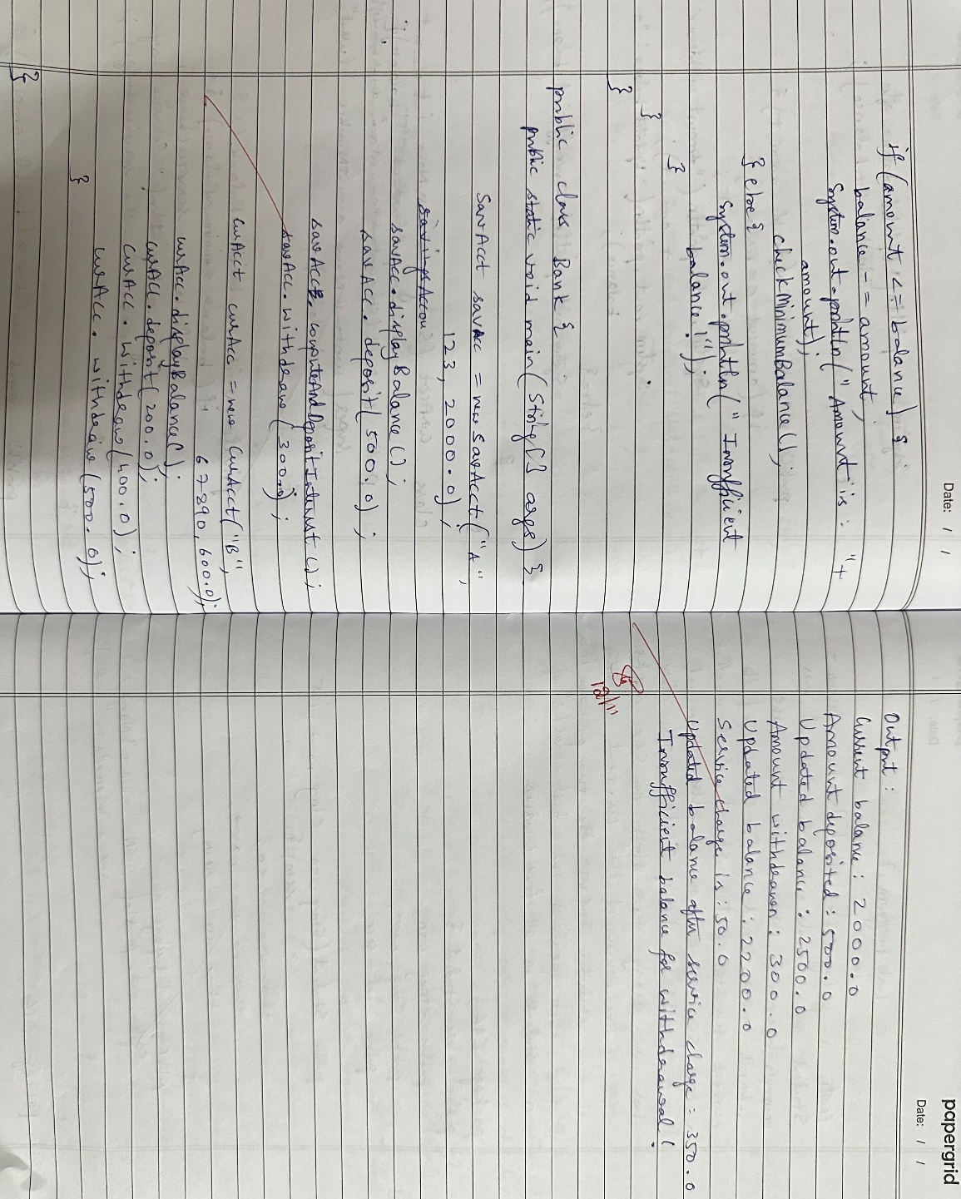

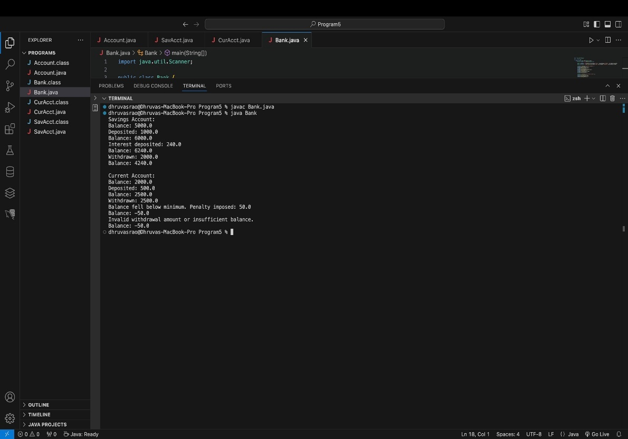

**OUTPUT 5**

**Program 6**

**CIE and SEE Packages Implementation**

Create a package CIE which has two classes - Personal and Internals. The class Personal has members like usn, name, sem. The class Internals has an array that stores the internal marks scored in five courses of the current semester of the student. Create another package SEE which has the class External which is a derived class of Personal. This class has an array that stores the SEE marks scored in five courses of the current semester of the student. Import the two packages in a file that declares the final marks of n students in all five courses.

**Source code:**

package CIE;

public class Internals {

public int[] internalMarks = new int[5];

public Internals(int[] marks) {

if (marks.length == 5) {

System.arraycopy(marks, 0, internalMarks, 0, 5);

} else {

throw new IllegalArgumentException("There must be exactly 5 internal marks.");

}

}

}

package CIE;

public class Student {

public String usn;

public String name;

public int sem;

public Student(String usn, String name, int sem) {

this.usn = usn;

this.name = name;

this.sem = sem;

}

}

package SEE;

import CIE.Student;

public class External extends Student {

public int[] seeMarks = new int[5];

public External(String usn, String name, int sem, int[] marks) {

super(usn, name, sem);

if (marks.length == 5) {

System.arraycopy(marks, 0, seeMarks, 0, 5);

} else {

throw new IllegalArgumentException("There must be exactly 5 SEE marks.");

}

}

}

import CIE.*;

import SEE.*;

import java.util.Scanner;

public class Main {

public static void main(String[] args) {

Scanner scanner = new Scanner(System.in);

System.out.print("Enter the number of students: ");

int n = scanner.nextInt();

scanner.nextLine();

External[] students = new External[n];

Internals[] internalMarks = new Internals[n];

for (int i = 0; i < n; i++) {

System.out.println("Enter details for student " + (i + 1));

System.out.print("USN: ");

String usn = scanner.nextLine();

System.out.print("Name: ");

String name = scanner.nextLine();

System.out.print("Semester: ");

int sem = scanner.nextInt();

System.out.print("Enter 5 internal marks: ");

int[] internal = new int[5];

for (int j = 0; j < 5; j++) {

internal[j] = scanner.nextInt();

}

internalMarks[i] = new Internals(internal);

System.out.print("Enter 5 SEE marks: ");

int[] external = new int[5];

for (int j = 0; j < 5; j++) {

external[j] = scanner.nextInt();

}

scanner.nextLine();

students[i] = new External(usn, name, sem, external);

System.out.println();

}

System.out.println("Final Marks:");

for (int i = 0; i < n; i++) {

System.out.println("Student: " + students[i].name);

for (int j = 0; j < 5; j++) {

int finalMark = internalMarks[i].internalMarks[j] + students[i].seeMarks[j];

System.out.println("Course " + (j + 1) + " Final Mark: " + finalMark);

}

System.out.println();

}

scanner.close();

}

}

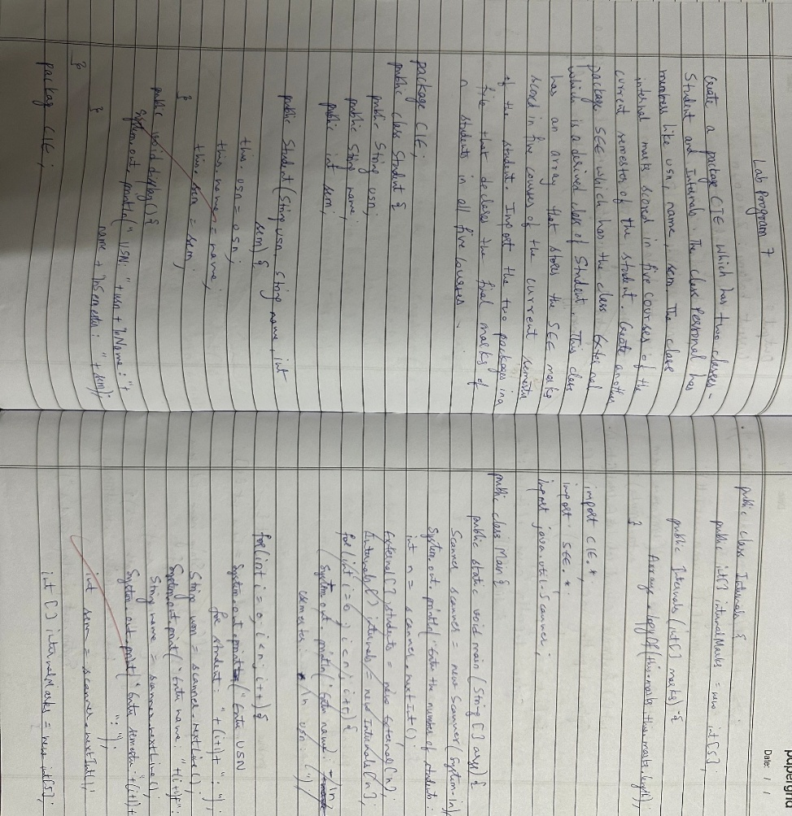

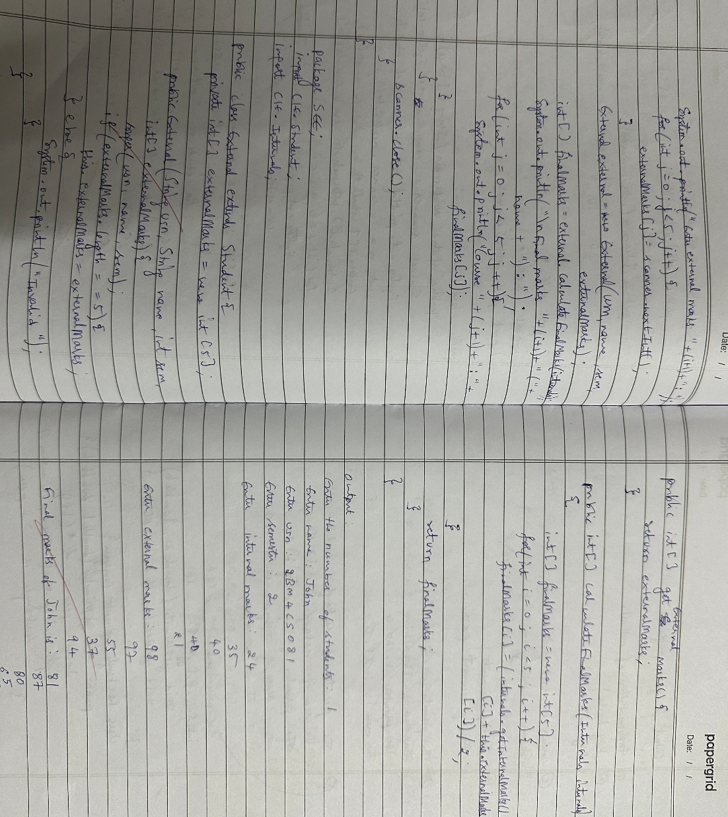

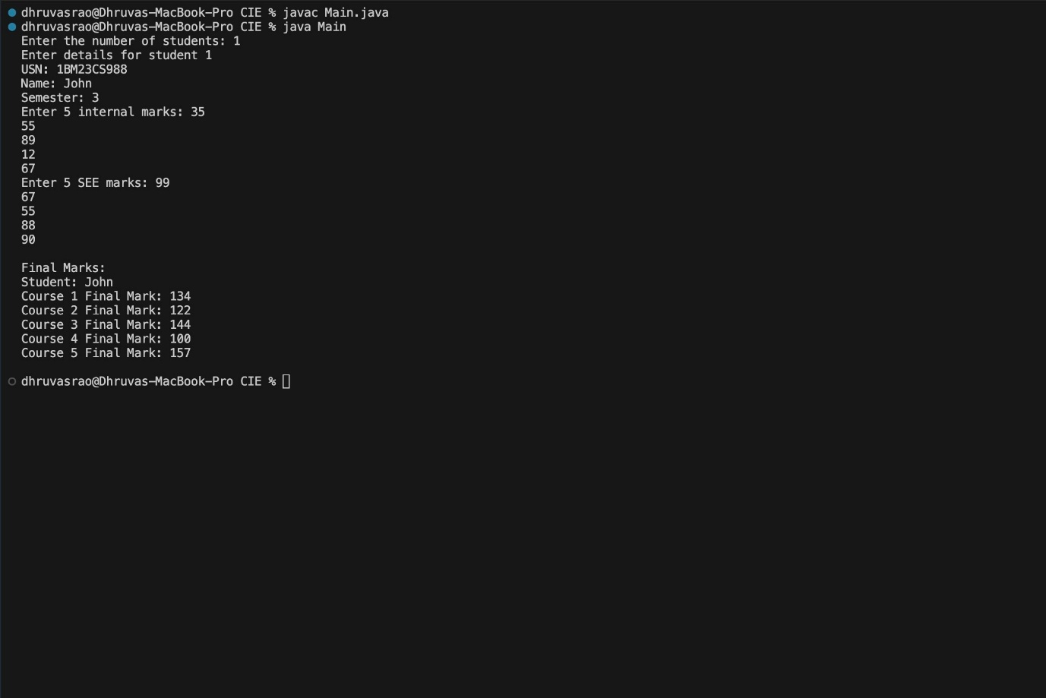

**OUTPUT 6**

**Program 7**

**Exception Handling**

Write a program that demonstrates handling of exceptions in inheritance tree. Create a base class called “Father” and derived class called “Son” which extends the base class. In Father class, implement a constructor which takes the age and throws the exception WrongAge( ) when the input age=father’s age.

**Source code:**

class WrongAgeException extends Exception {

public WrongAgeException(String message) {

super(message);

}

}

class Father {

protected int age;

public Father(int age) throws WrongAgeException {

if (age < 0) {

throw new WrongAgeException("Age cannot be negative for Father.");

}

this.age = age;

}

public int getAge(){

return age;

}

}

class Son extends Father {

public int sonAge;

public Son(int fatherAge, int sonAge) throws WrongAgeException {

super(fatherAge);

if (sonAge < 0) {

throw new WrongAgeException("Age cannot be negative for Son.");

}

if (sonAge >= fatherAge) {

throw new WrongAgeException("Son's age cannot be greater than or equal to Father's age.");

}

this.sonAge = sonAge;

}

}

public class Main{

public static void main(String[] args) {

try {

Father father = new Father(45);

System.out.println("Father's age is valid.");

Son son = new Son(45, 20);

System.out.println("Son's age is valid.");

} catch (WrongAgeException e) {

System.out.println("Exception: " + e.getMessage());

}

try {

Father invalidFather = new Father(-5);

} catch (WrongAgeException e) {

System.out.println("Exception: " + e.getMessage());

}

try {

Son invalidSon = new Son(40, 45);

} catch (WrongAgeException e) {

System.out.println("Exception: " + e.getMessage());

}

}

}

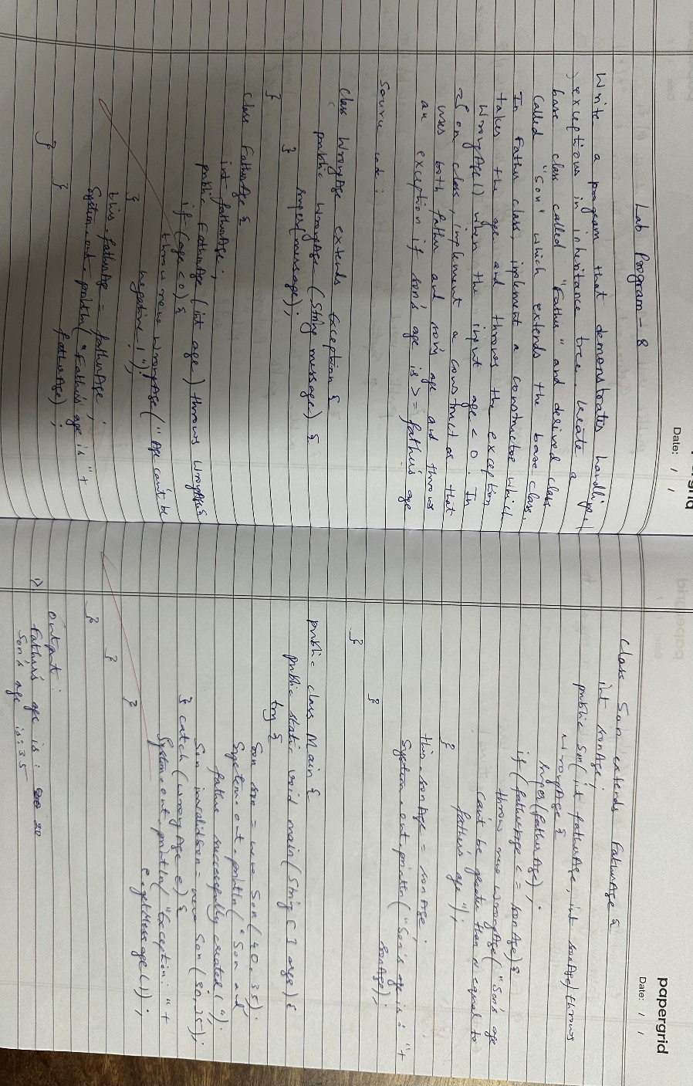

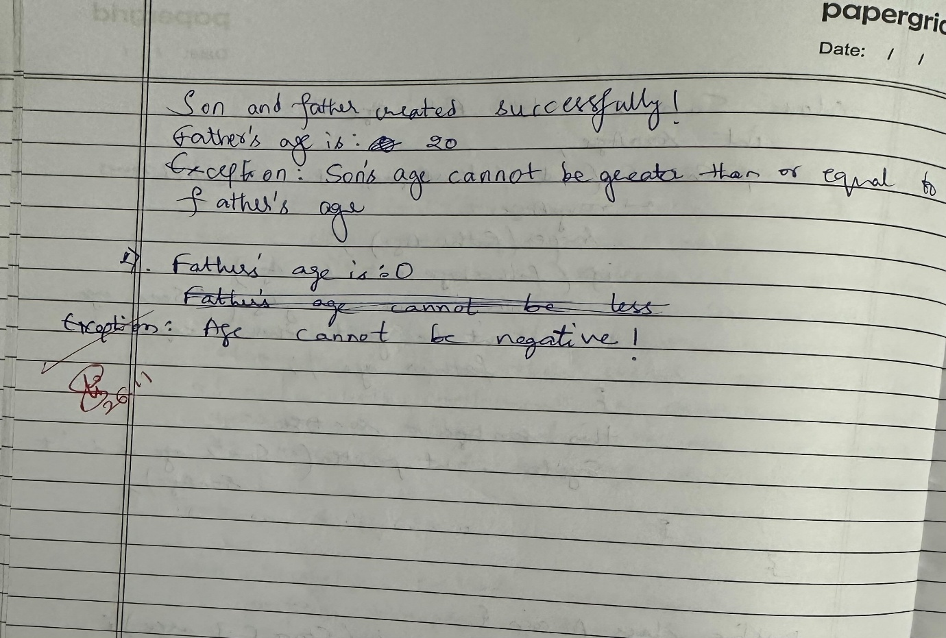

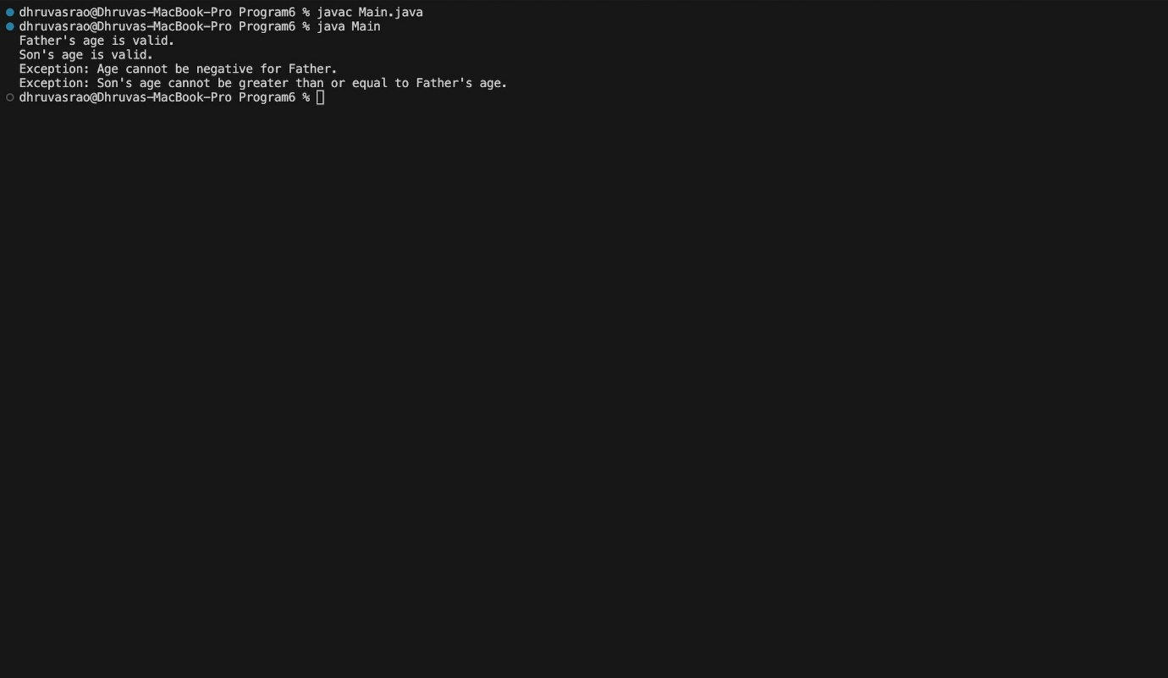

**OUTPUT 7**

**Program 8**

**Thread Program Implementation**

Write a program which creates two threads, one thread displaying “BMS College of Engineering” once every ten seconds and another displaying “CSE” once every two seconds

**Source code:**

class DisplayMessage extends Thread {

private String message;

private int interval;

public DisplayMessage(String message, int interval) {

this.message = message;

this.interval = interval;

}

@Override

public void run() {

try {

while (true) {

System.out.println(message);

Thread.sleep(interval);

}

} catch (InterruptedException e) {

System.out.println("Thread interrupted: " + message);

}

}

}

public class Main {

public static void main(String[] args) {

Thread thread1 = new DisplayMessage("BMS College of Engineering", 10000);

Thread thread2 = new DisplayMessage("CSE", 2000);

thread1.start();

thread2.start();

}

}

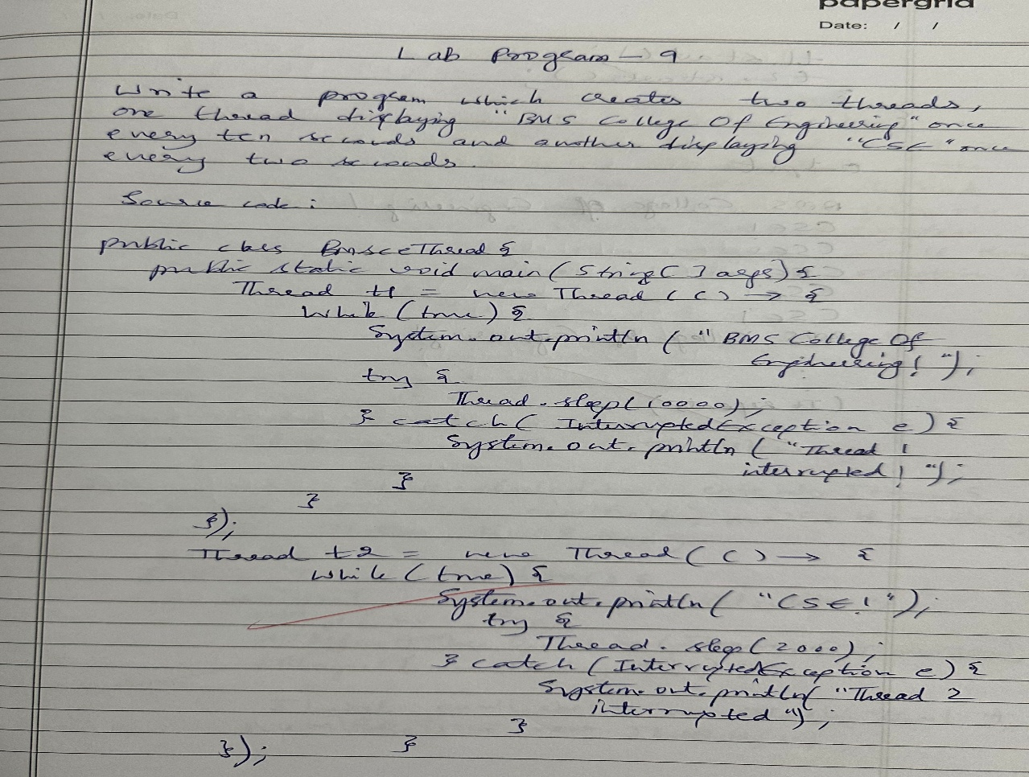

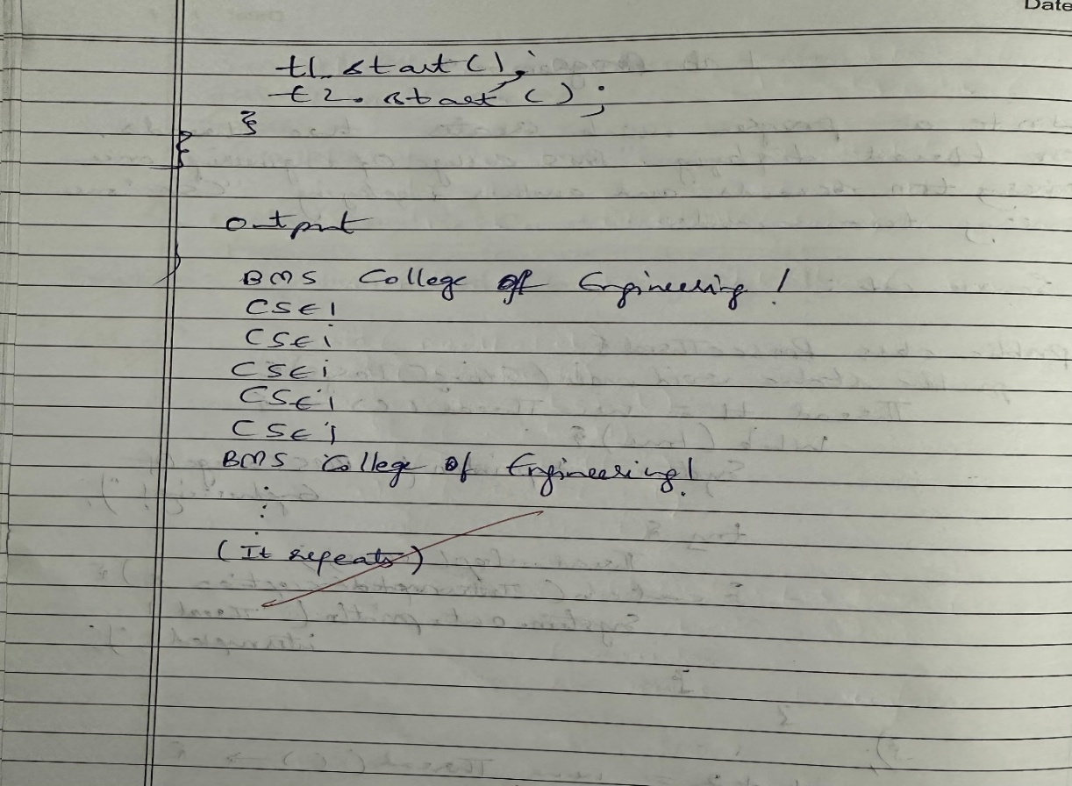

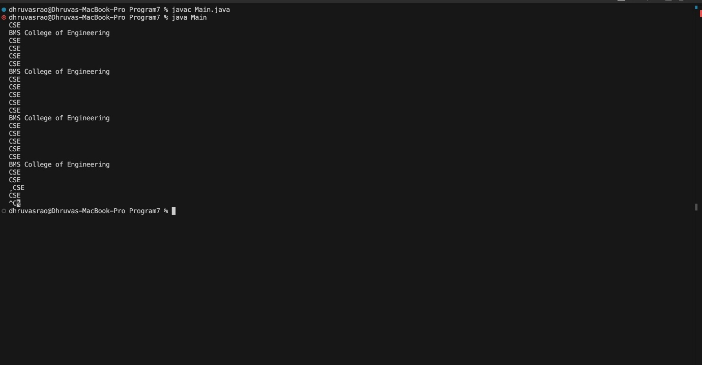

**OUTPUT 8**

**Program 9**

**Interface Implementation**

Write a program that creates a user interface to perform integer divisions. The user enters two numbers in the text fields, Num1 and Num2. The division of Num1 and Num2 is displayed in the Result field when the Divide button is clicked. If Num1 or Num2 were not an integer, the program would throw a NumberFormatException. If Num2 were Zero, the program would throw an Arithmetic Exception Display the exception in a message dialog box.

**Source code:**

import javax.swing.*;

import java.awt.*;

import java.awt.event.ActionEvent;

import java.awt.event.ActionListener;

public class IntegerDivisionUI {

public static void main(String[] args) {

JFrame frame = new JFrame("Integer Division");

frame.setDefaultCloseOperation(JFrame.EXIT_ON_CLOSE);

frame.setSize(400, 200);

JLabel label1 = new JLabel("Num1:");

JTextField num1Field = new JTextField(10);

JLabel label2 = new JLabel("Num2:");

JTextField num2Field = new JTextField(10);

JButton divideButton = new JButton("Divide");

JTextField resultField = new JTextField(15);

resultField.setEditable(false);

divideButton.addActionListener(new ActionListener() {

@Override

public void actionPerformed(ActionEvent e) {

try {

int num1 = Integer.parseInt(num1Field.getText());

int num2 = Integer.parseInt(num2Field.getText());

if (num2 == 0) {

throw new ArithmeticException("Division by zero");

}

int result = num1 / num2;

resultField.setText(String.valueOf(result));

} catch (NumberFormatException ex) {

JOptionPane.showMessageDialog(frame, "Please enter valid integers.", "Input Error", JOptionPane.ERROR_MESSAGE);

} catch (ArithmeticException ex) {

JOptionPane.showMessageDialog(frame, "Cannot divide by zero.", "Arithmetic Error", JOptionPane.ERROR_MESSAGE);

}

}

});

JPanel panel = new JPanel();

panel.setLayout(new GridLayout(4, 2, 5, 5));

panel.add(label1);

panel.add(num1Field);

panel.add(label2);

panel.add(num2Field);

panel.add(new JLabel("Result:"));

panel.add(resultField);

panel.add(new JLabel());

panel.add(divideButton);

frame.add(panel);

frame.setVisible(true);

}

}

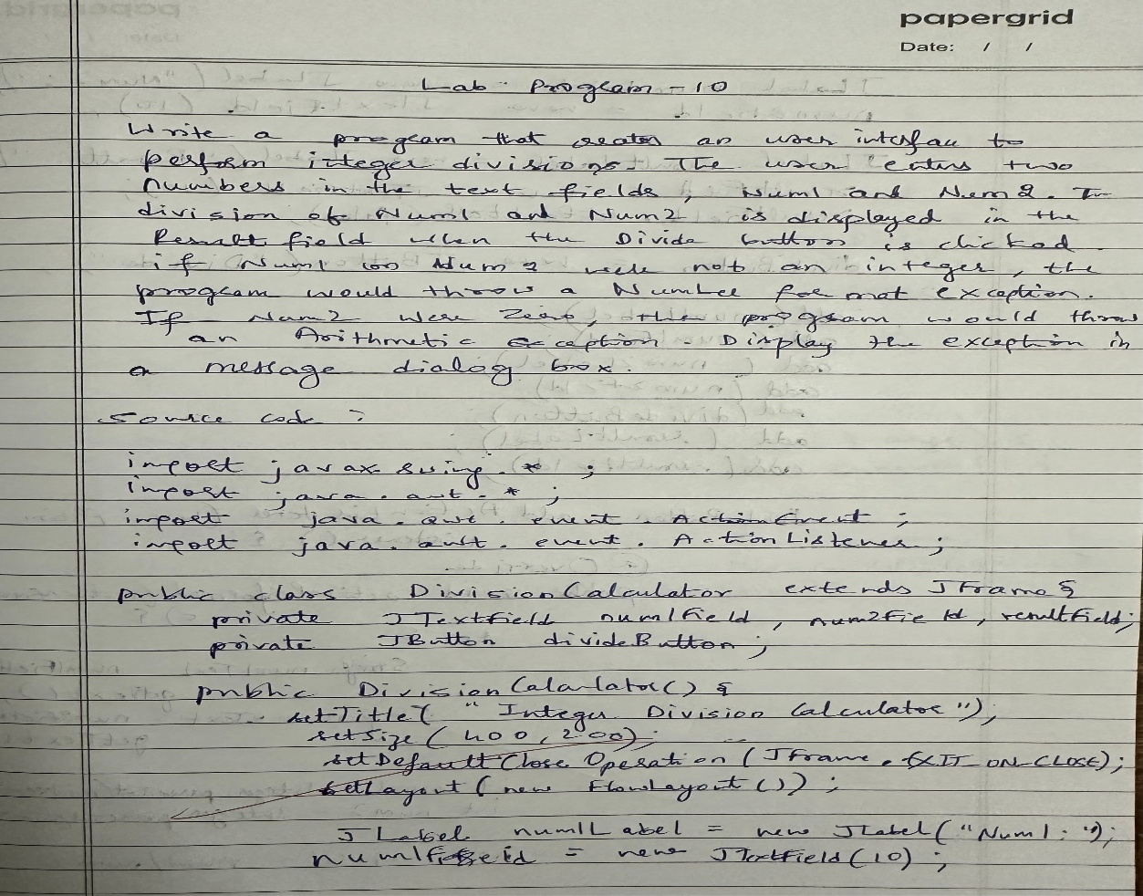

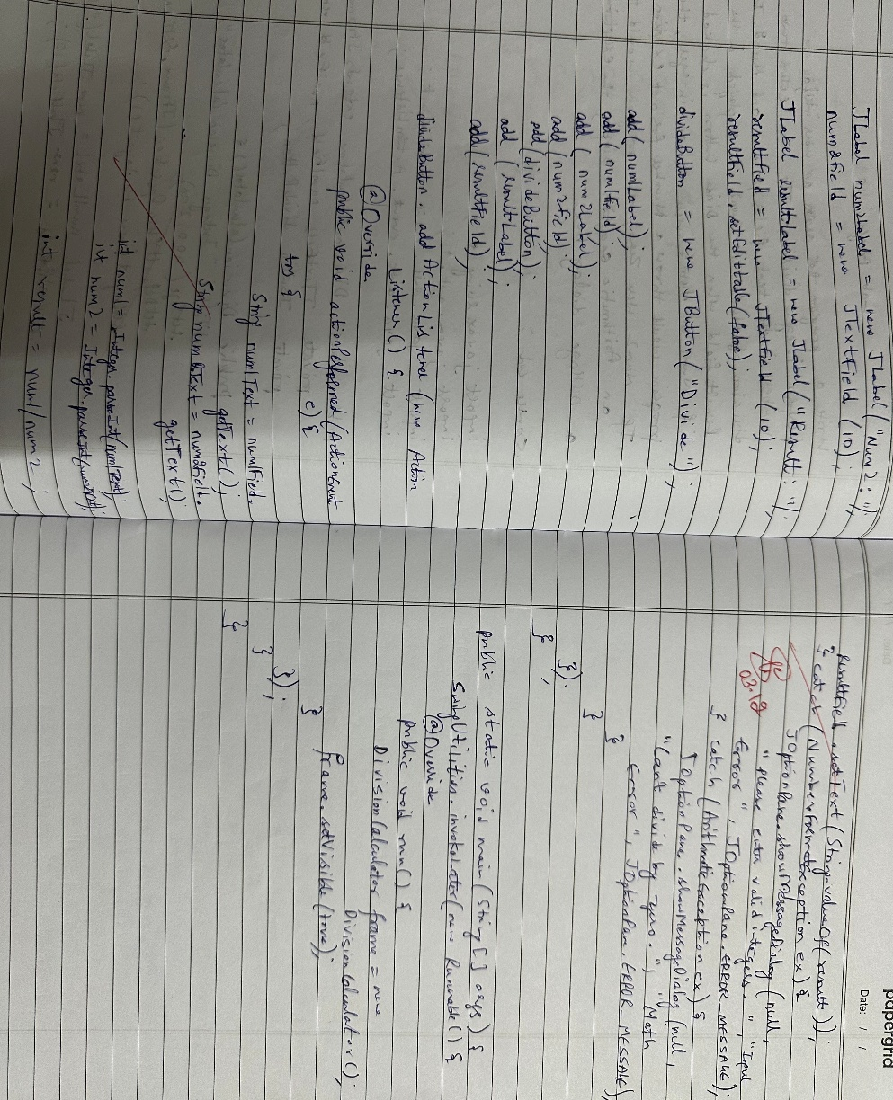

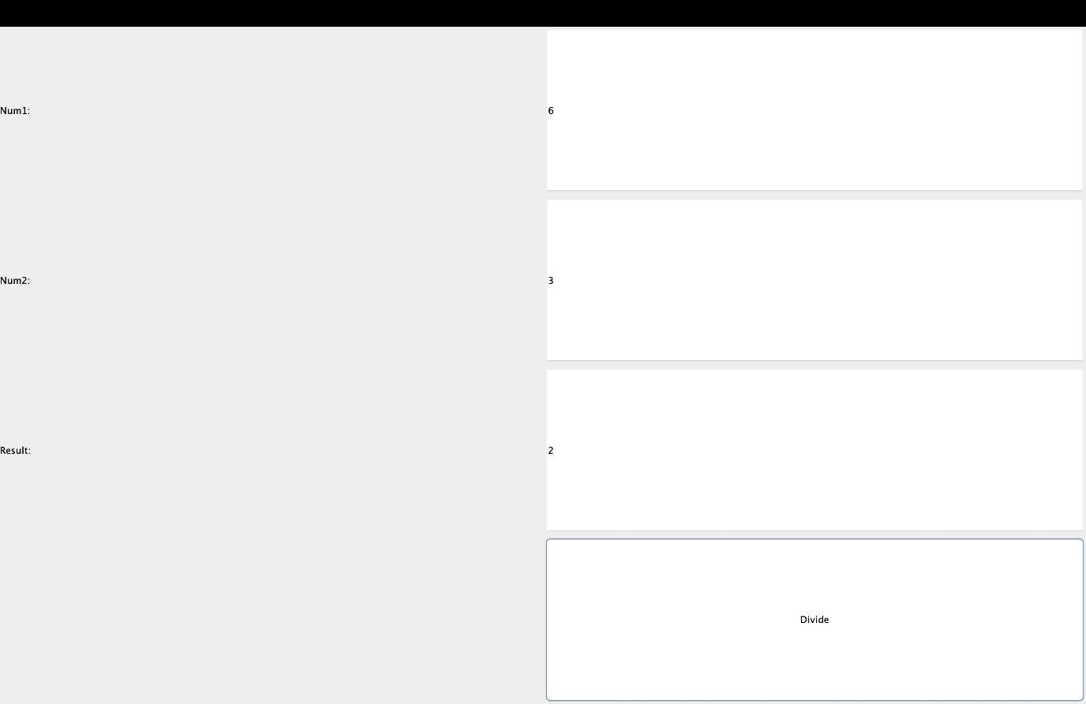

**OUTPUT 9**

**Program 10**

**Inter Process Communication and Deadlock**

Demonstrate Inter process Communication and deadlock

**Source code:**

class SharedResource {

public synchronized void methodA(SharedResource resource) {

System.out.println(Thread.currentThread().getName() + " is executing methodA");

try {

Thread.sleep(100);

} catch (InterruptedException e) {

System.out.println("InterruptedException in methodA");

}

System.out.println(Thread.currentThread().getName() + " is trying to call methodB on " + resource);

resource.methodB(this);

}

public synchronized void methodB(SharedResource resource) {

System.out.println(Thread.currentThread().getName() + " is executing methodB");

try {

Thread.sleep(100);

} catch (InterruptedException e) {

System.out.println("InterruptedException in methodB");

}

System.out.println(Thread.currentThread().getName() + " is trying to call methodA on " + resource);

resource.methodA(this);

}

}

public class IPCDeadlockDemo {

public static void main(String[] args) {

SharedResource resource1 = new SharedResource();

SharedResource resource2 = new SharedResource();

Thread thread1 = new Thread(() -> resource1.methodA(resource2), "Thread-1");

Thread thread2 = new Thread(() -> resource2.methodB(resource1), "Thread-2");

thread1.start();

thread2.start();

}

}

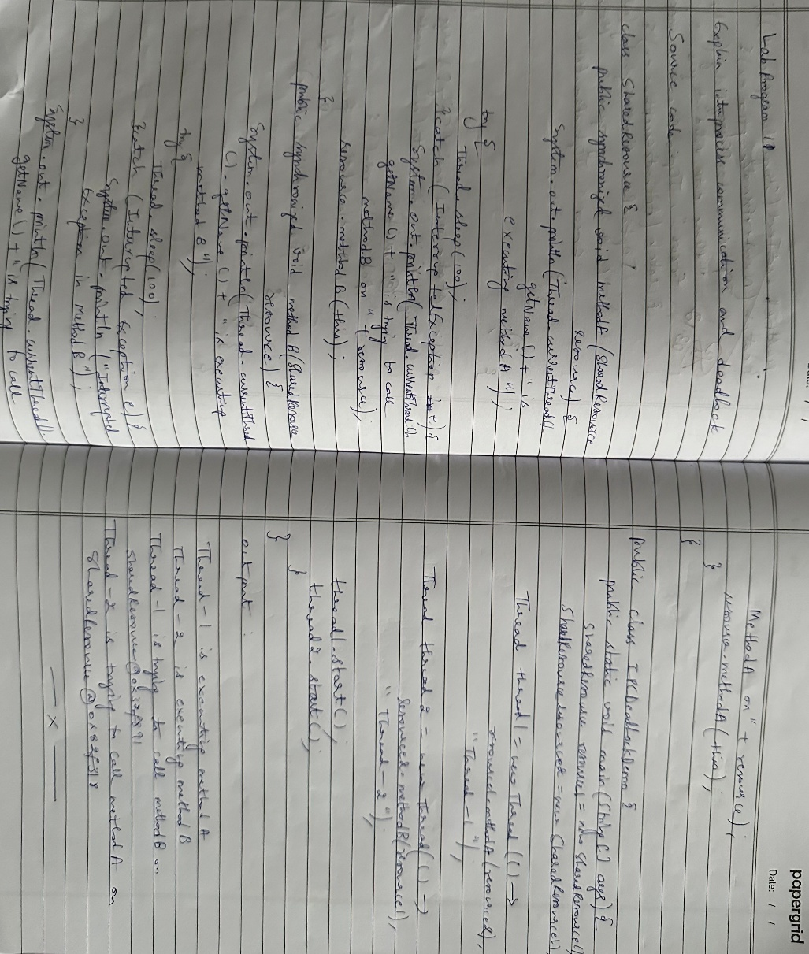

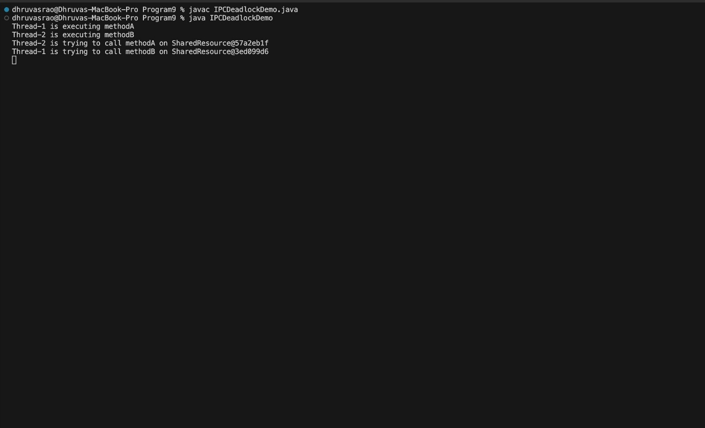

OUTPUT 10